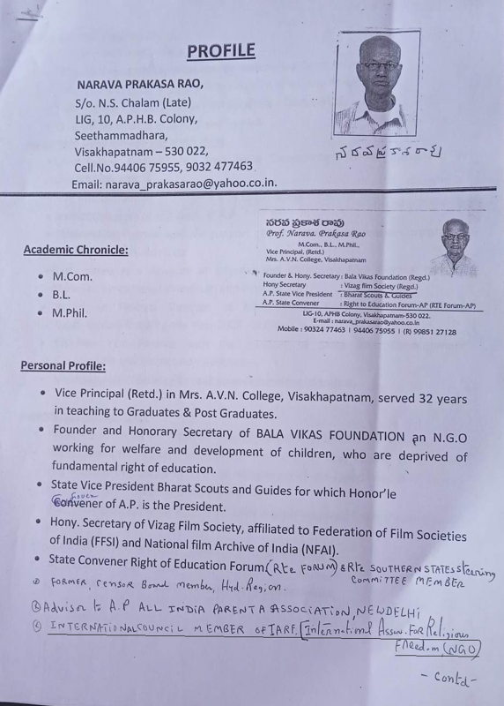

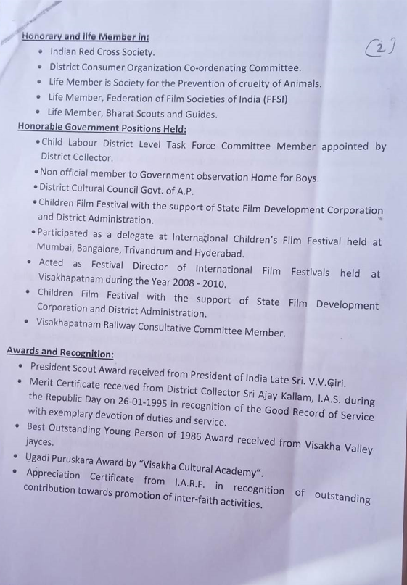

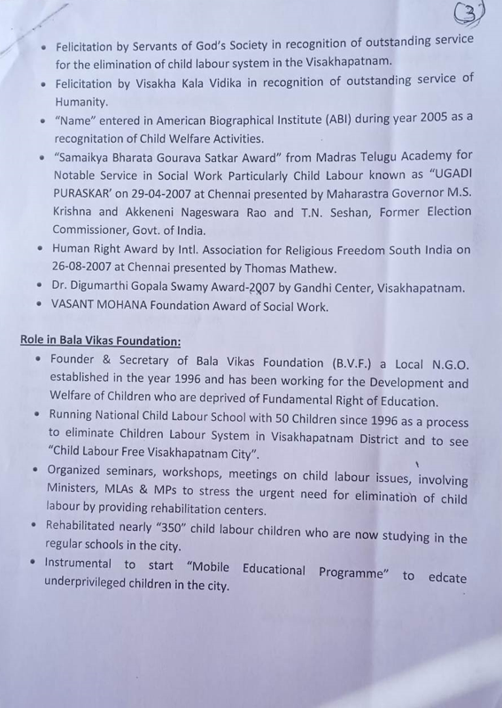

: 4 :

**Visit to Abroad:**

• Visited "Budapest" Hungary, during the year 1996 from Andhra Pradesh as an Indian Delegate for IARF World Congress where Swamy Agnevesh also attended as an Indian delegate.

Visited "Katmandu" of Nepal.

**Strengths:**

Good Communication Skills.

Excellent Inter Personal Skills.

Inquisitive, Innovative & Initiative.

Self Motivation and Resourceful.

**Programmes Organized by BV Foundation:**

This is to convey that I have been involved very actively in RF, as well as Human rights education Project and Inter faith work since 20 years in   this region. My specialization in young Adult programme since I am in teaching profession and has good fortune to promote interfaith work among youth and students in our region.

        So far BV Foundation for peace and harmony has organized novel and attractive programmes which are available in IARF website and public platform.

Some of them are

1) All the National and international festivals

2) UN declaration on elimination of all forms of intolerance and discrimination  based on religion  -- Meetings

3) Hiroshima and Nagasaki disaster days 4 day programme 6-9th August

4) Human Rights Day December 10

5) Pulse polio immunization event involving all religious groups

6) International Peace Day September 21st

7) International Non violence day October 2nd.

8) Discussion on the relevance of religion on contemporary social problems

9) Visit to religious places

10) Symbolic white wash of temple and Mosque

: 5 :

**Personal Details:**

Name : NARAVA PRAKASA RAO

Father's Name : Late N.S.Chalam

Date of Birth : 15-04-1950

Material Status : Married

Gender : Male

Family : One Son & One Daughter Happily married and settled at Hyderabad

Nationality : Indian

Religion : Hindu

Linguistic Skills : English, Telugu, Hindi.

**Declaration:**

I hereby declare that the information furnished above is true and correct to the best of my knowledge and belief.

**Place:** Visakhapatnam,

**Date:** 28.10.2023

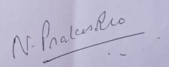

(NARAVA PRAKASA RAO)